RainNest

Mini Project Report

Submitted by

Don Shaji
Reg. No.: AJC23MCA-I030

In Partial fulfillment for the Award of the Degree of
INTEGRATED MASTER OF COMPUTER APPLICATIONS

(INMCA)



AMAL JYOTHI COLLEGE OF ENGINEERING AUTONOMOUS
KANJIRAPPALLY

[Approved by AICTE, Accredited by NAAC with A+.
Koovappally, Kanjirappally, Kottayam, Kerala – 686518]

2025-2026

DEPARTMENT OF COMPUTER APPLICATIONS

AMAL JYOTHI COLLEGE OF ENGINEERING AUTONOMOUS
KANJIRAPPALLY



CERTIFICATE

This is to certify that the Project report, “RainNest” is the bona fide work of
Don Shaji (Regno: AJC23MCA-I030) carried out in partial fulfillment of the requirements for the award of the Degree of Integrated Master of Computer Applications at Amal Jyothi College of Engineering Autonomous, Kanjirappally. The project was undertaken during the period from December 01, 2025 to March 27, 2026.

Ms. Merin Chacko Ms. Meera Rose Mathew
Internal Guide Coordinator

Dr. Bijimol T K
Head of the Department

DECLARATION

I hereby declare that the project report “RainNest” is a bona fide work done at Amal Jyothi College of Engineering Autonomous, Kanjirappally, towards the partial fulfilment of the requirements for the award of the Integrated Master of Computer Applications (INMCA) during the period from December 01, 2025 to March 27, 2026.

Date: DON SHAJI
KANJIRAPPALLY Reg: AJC23MCA-I030

ACKNOWLEDGEMENT

First and foremost, I thank God almighty for his eternal love and protection throughout the project. I take this opportunity to express my gratitude to all who helped me in completing this project successfully. It has been said that gratitude is the memory of the heart. I wish to express my sincere gratitude to our Director (Administration) Rev. Fr. Dr. Roy Abraham Pazhayaparampil and Principal Dr. Lillykutty Jacob for providing good faculty for guidance.

I owe a great depth of gratitude towards our Head of the Department Dr. Bijimol T K for helping us. I extend my whole hearted thanks to the project coordinator Ms. Meera Rose Mathew for her valuable suggestions and for overwhelming concern and guidance from the beginning to the end of the project. I would also express sincere gratitude to my guide Ms. Merin Chacko for his inspiration and helping hand.

I thank our beloved teachers for their cooperation and suggestions that helped me throughout the project. I express my thanks to all my friends and classmates for their interest, dedication, and encouragement shown towards the project. I convey my hearty thanks to my family for the moral support, suggestions, and encouragement to make this venture a success.

DON SHAJI

ABSTRACT

Unpredictable weather often leaves urban commuters unprepared, leading to the frequent use of disposable plastic umbrellas that contribute to environmental waste. To address this issue, RainNest proposes an IoT-based Smart Umbrella Rental System that provides automated and real-time access to reusable umbrellas at public locations. The system uses a NodeMCU ESP8266 microcontroller with an analog sensing network to identify umbrellas by measuring resistance values. When a user interacts with the station, the device sends status updates through the HiveMQ MQTT cloud broker, ensuring fast and reliable communication between the hardware and cloud services.

The software infrastructure is built using Firebase and a Flutter-based middleware service. The middleware receives hardware data from the MQTT broker, verifies umbrella IDs, and synchronizes the information with Firestore and Realtime Database. It also manages important functions such as calculating rental duration, verifying user wallet balances, and tracking umbrella inventory. Whenever an umbrella is removed or returned, the system updates the database instantly to maintain real-time synchronization.
RainNest supports two types of users: Administrators and General Users. Administrators can monitor station status, manage inventory, and track revenue. General users interact through a mobile application where they can scan QR codes at stations, rent umbrellas, and manage a digital wallet. The system also includes a coin-based reward mechanism to encourage proper returns.

The Flutter mobile application follows the Material 3 design system and uses Provider state management to update rental information and wallet balances instantly. Visual indicators such as Red (Locked), Orange (Processing), and Green (Success) help users understand the rental status clearly.

Overall, RainNest combines IoT hardware, cloud infrastructure, and a user-friendly mobile interface to provide a sustainable and convenient umbrella rental solution. The system promotes reusable resources, reduces environmental waste, and improves accessibility to weather protection in urban environments.
.

CONTENT

SL. NO |  | TOPIC | PAGE NO
1 |  | INTRODUCTION
1.1 |  | PROJECT OVERVIEW
1.2 |  | PROJECT SPECIFICATION
2 |  | SYSTEM STUDY
2.1 |  | INTRODUCTION
2.2 |  | EXISTING SYSTEM
2.3 |  | DRAWBACKS OF EXISTING SYSTEM
2.4 |  | PROPOSED SYSTEM
2.5 |  | ADVANTAGES OF PROPOSED SYSTEM
3 |  | REQUIREMENT ANALYSIS
3.1 |  | FEASIBILITY STUDY
3.1.1 |  | ECONOMICAL FEASIBILITY
3.1.2 |  | TECHNICAL FEASIBILITY
3.1.3 |  | BEHAVIORAL FEASIBILITY
3.1.4 |  | FEASIBILITY STUDY QUESTIONNAIRE
3.1.5 |  | GEOTAGGED PHOTOGRAPH
3.2 |  | SYSTEM SPECIFICATION
3.2.1 |  | HARDWARE SPECIFICATION
3.2.2 |  | SOFTWARE SPECIFICATION
3.3 |  | SOFTWARE DESCRIPTION
3.3.1 |  | PHP
3.3.2 |  | MYSQL
4 |  | SYSTEM DESIGN
4.1 |  | INTRODUCTION
4.2 |  | UML DIAGRAM
4.2.1 |  | USE CASE DIAGRAM
4.2.2 |  | SEQUENCE DIAGRAM
4.2.3 |  | STATE CHART DIAGRAM
4.2.4 |  | ACTIVITY DIAGRAM
4.2.5 |  | CLASS DIAGRAM
4.2.6 |  | OBJECT DIAGRAM
4.2.7 |  | COMPONENT DIAGRAM
4.2.8 |  | DEPLOYMENT DIAGRAM
4.2.9 |  | COLLABORATION DIAGRAM
4.3 |  | USER INTERFACE DESIGN USING FIGMA
4.4 |  | DATABASE DESIGN
5 |  | SYSTEM TESTING
5.1 |  | INTRODUCTION
5.2 |  | TEST PLAN
5.2.1 | UNIT TESTING
5.2.2 | INTEGRATION TESTING
5.2.3 | VALIDATION TESTING
5.2.4 | USER ACCEPTANCE TESTING
5.2.5 | AUTOMATION TESTING
5.2.6 | SELENIUM TESTING
6 | IMPLEMENTATION
6.1 | INTRODUCTION
6.2 | IMPLEMENTATION PROCEDURE
6.2.1 | USER TRAINING
6.2.2 | TRAINING ON APPLICATION SOFTWARE
6.2.3 | SYSTEM MAINTENANCE
7 | CONCLUSION & FUTURE SCOPE
7.1 | CONCLUSION
7.2 | FUTURE SCOPE
8 | BIBLIOGRAPHY
9 | APPENDIX
9.1 | SAMPLE CODE
9.2 | SCREEN SHOTS
9.3 | GEO-TAGGED PHOTOS PANEL REVIEW 1 & 2
9.4 | GIT LOG

List of Abbreviations

CHAPTER 1

INTRODUCTION

PROJECT OVERVIEW

Floods and sudden increases in water levels can cause serious damage to human life, property, and the environment. In many places, monitoring water levels is still done manually, which makes it difficult to detect sudden changes quickly. Because of this, an automated system that can monitor water levels and provide early warnings is very important.

The IoT-Based Water Level Monitoring and Alert System is designed to monitor water levels continuously and provide alerts when the water reaches critical levels. In this system, sensors are placed at different heights to detect the presence of water. When the water level rises and touches these sensors, the system detects the change and sends the information to a connected web application.

The system consists of hardware components such as sensors, a microcontroller, and communication modules that transmit the collected data. The software part includes a web application where users can view the water level status in real time and receive alert messages if the water level crosses a predefined limit.

This project provides an automated and efficient way to monitor water levels remotely. It can be useful in areas prone to flooding, water tanks, reservoirs, and drainage systems. By providing early alerts, the system helps in taking timely action and improving overall safety.

PROJECT SPECIFICATION

The IoT-Based Water Level Monitoring and Alert System is designed to monitor water levels and provide real-time alerts when the water reaches predefined levels. The system uses sensors placed at different heights to detect the presence of water. When the water touches these sensors, the system identifies the current level and sends the information to a connected web application for monitoring.

The hardware part of the system includes water level detection sensors, a microcontroller for processing the sensor data, and a communication module to transmit the information. The sensors are placed at multiple levels inside a container or water body to detect the rise in water level step by step. The microcontroller continuously reads the sensor values and determines the current water level status.

The software component consists of a web-based application that displays the water level information to users. The application allows users to view real-time data and receive notifications when the water level crosses a certain threshold. The system is designed to support both user and administrator access, where the administrator can monitor multiple devices and manage alert settings.

The project aims to provide an automated, reliable, and cost-effective solution for monitoring water levels in areas such as flood-prone regions, reservoirs, drainage systems, and water storage tanks. The integration of IoT technology allows remote monitoring and quick response to potential flood situations.

CHAPTER 2

SYSTEM STUDY

INTRODUCTION

In this project, the system study focuses on analyzing the problems associated with traditional water level monitoring methods. In many areas, water levels are monitored manually, which can lead to delays in detecting sudden increases in water level. This delay may result in damage to property and risk to human life, especially in flood-prone areas.

Through system study, the requirements for an automated monitoring solution are identified. The proposed system uses IoT technology, sensors, and a web-based application to continuously monitor water levels and provide timely alerts. This helps in improving monitoring efficiency and enables users to take preventive actions when water levels rise beyond safe limits.

EXISTING SYSTEM
In the existing system, water level monitoring is mostly carried out using manual methods or simple measuring devices. In many areas, people regularly check the water level in rivers, reservoirs, or tanks by physical observation. This process requires human involvement and continuous monitoring, which can be time consuming and inefficient.
Manual monitoring systems are not capable of providing real-time information or early warning alerts. If the water level rises suddenly due to heavy rainfall or other reasons, it may not be noticed immediately. This delay can lead to serious problems such as flooding, property damage, and risk to human safety.
Some traditional systems use basic measuring scales or mechanical indicators to show the water level, but they do not provide remote monitoring or automatic notification features. Because of these limitations, it becomes difficult to monitor water levels continuously and respond quickly during emergency situations.
Therefore, the need for an automated and intelligent monitoring system arises to improve efficiency, provide real-time updates, and reduce the dependency on manual observation.

2.2.1 NATURAL SYSTEM STUDIED

The natural system studied in this project is the behavior of water level changes in a water body such as rivers, reservoirs, tanks, or drainage systems. In nature, the water level increases mainly due to factors such as heavy rainfall, continuous inflow of water, and overflow from nearby water sources. When the amount of incoming water becomes greater than the capacity of the water body, the water level rises and may eventually lead to flooding.

Observing how water rises gradually in different levels helps in understanding how floods develop. Normally, water first reaches a safe level, then moves to warning levels, and finally reaches a critical level where overflow may occur. Monitoring these different stages is important in order to take preventive measures before the situation becomes dangerous.

In this project, the natural behavior of rising water levels is simulated using sensors placed at different heights. These sensors detect the presence of water at each level and send the information to the system. By studying this natural pattern, the system can identify the current water level and generate alerts when the water reaches predefined thresholds. This helps in providing early warnings and improving safety in flood-prone areas.

2.2.2 DESIGNED SYSTEM STUDIED

The designed system studied in this project is an IoT-based water level monitoring and alert system that automatically detects and reports changes in water levels. The system is developed to overcome the limitations of manual monitoring by using sensors, a microcontroller, and a web-based application for real-time monitoring.

In the designed system, multiple sensors are placed at different heights to detect the presence of water at various levels. When the water reaches a particular sensor, the microcontroller reads the signal and determines the current water level. The collected data is then transmitted to the web application through a communication module.

The web application displays the water level status and allows users to monitor the system remotely. If the water level reaches a predefined threshold, the system generates an alert message to notify users. This designed system provides continuous monitoring, faster response, and improved reliability compared to traditional methods.

DRAWBACKS OF EXISTING SYSTEM

- Manual Monitoring
The existing system mainly depends on manual observation to check water levels. This requires continuous human involvement and increases the chances of human error.
- Lack of Real-Time Monitoring
Traditional methods do not provide real-time updates about the water level. As a result, sudden increases in water level may not be detected immediately.
- Time Consuming Process
Regularly checking water levels manually takes a lot of time and effort. This makes the monitoring process inefficient.
- No Automatic Alert System
The existing system does not provide automatic notifications or warning messages when the water level rises to dangerous levels.
- No Remote Access
Users must be physically present at the location to observe the water level. This makes monitoring difficult, especially in remote or risky areas.
- Higher Risk During Emergencies
Due to delayed detection and lack of alerts, it becomes difficult to take quick action during flood situations, increasing the risk of damage and danger.

PROPOSED SYSTEM

The proposed system is an IoT-based water level monitoring and alert system designed to automatically monitor the water level and provide timely alerts when the level rises beyond predefined limits. In this system, sensors are placed at different heights to detect the presence of water at various levels. When the water reaches a particular sensor, the system detects the change and determines the current water level.

The sensor data is processed using a microcontroller, which continuously reads the signals from the sensors. The collected information is then transmitted to a web-based application using IoT technology. This allows users to monitor the water level in real time from any location.

In addition, the system provides automatic alert notifications when the water level reaches warning or critical stages. This helps users take immediate action to prevent possible flooding or damage. The proposed system improves efficiency, reduces manual effort, and provides a reliable solution for continuous water level monitoring

ADVANTAGES OF PROPOSED SYSTEM

- Automatic Monitoring
The system automatically monitors the water level without the need for continuous human observation.
- Real-Time Monitoring
It provides real-time updates about the water level through the connected web application.
- Early Warning System
The system sends alerts when the water level reaches predefined warning or critical levels.
- Remote Accessibility
Users can monitor the water level from anywhere using the web application.
- Improved Accuracy
Sensors detect the presence of water accurately, reducing the chances of human error.
- Time Efficient
Automated monitoring saves time and effort compared to manual checking.
- Cost Effective
The system uses simple and affordable components, making it economical to implement.
- Better Safety
Early alerts help users take preventive actions and reduce the risk of flooding or damage.

CHAPTER 3

REQUIREMENT ANALYSIS

FEASIBILITY STUDY

AquaSafe is an IoT-enabled flood monitoring and alert solution designed to detect
rising water levels in flood-prone regions and deliver early warnings to local
governing bodies such as panchayats. The system leverages ESP32
microcontrollers, water-level sensors, LoRaWAN communication, and a real
time dashboard to ensure timely decision-making to reduce damage and loss
during flood events.

Economical Feasibility

- Implementation cost is moderate, involving sensors, ESP32 modules, LoRa module and backend development.
- Once deployed, the system operates at very low communication costs due to LoRaWAN’s low-power protocol.
- The solution can save substantial cost by preventing infrastructure damage and loss of life during floods.

Technical Feasibility

- The ESP32 microcontroller, ultrasonic/pressure water-level sensors, and LoRaWAN are reliable and widely used technologies for long-distance, low-power transmission.
- Backend development using PHP and MySQL is supported by available expertise and is easily scalable.
- Required dashboards and mapping APIs are technically implementable.

Behavioral Feasibility

Behavioral feasibility refers to how well the proposed system will be accepted and used by the people who interact with it. The AquaSafe flood monitoring system is designed to be simple and user friendly so that local authorities such as panchayats and emergency response teams can easily understand and operate the system.
The dashboard interface presents water level information using clear indicators, charts, and alert messages, which helps users quickly understand the current situation without requiring advanced technical knowledge. The system also reduces the need for manual monitoring, allowing officials to receive alerts automatically and respond more effectively during flood situations.
Since the system provides accurate and timely information, it helps build trust among users and encourages them to rely on the system for decision making. With minimal training, users can comfortably adopt the AquaSafe system for monitoring water levels and managing flood risks

    - Feasibility Study Questionnaire

- During the current flood situations, what are the major difficulties you face in monitoring water levels across different areas?
Actually, they don’t have a proper monitoring system in our locality. The water level rises in the river during the rainy season and when the dam is opened. So, they manually watch everywhere to see whether there the water level has increased or not.

- How do you currently receive information about rising water levels, and how reliable and timely is that information?
They don’t have a proper monitoring system, if there are chances for flood they make road announcement on the areas about the flood alert information.

- How do you currently identify and inform nearby safe evacuation points to the public?
They have some common places like factory warehouse, gov schools where they will evacuate the citizens safely. To use warehouses, prior permission must be obtained from the tea factory management.

- Do you face difficulty in tracking which areas or households need immediate rescue first?
Usually there are some areas where water causes damages to the people and the surroundings, first they will evacuate the people rom those places and then the rest.

- What procedure do you take first to evacuate the people from the affected areas?
Firstly, a road announcement will be provided to every places, about the alert, and also if the dam is about open by that time too, they will provide the announcement and then the get permissions from the factory authorities to provide their warehouse as camps, then by sending vehicles are then sent to flood-prone areas to pick up people and move them to safe shelters.

- Are the citizens facing difficulty in getting information about the water level in your own area in real time?
Yes, they do, as they don’t have a proper monitoring system they get the information only through mic announcements. At night if anything such happens, they find it difficult to get the information and during that time they won’t be having proper power supply, which leads to worst situation.

- What are the difficulties you face during this situation?
Power supply is the main issue, because there may not be power supply for many days and their mobile charge drains, and they won’t be able to communicate with anyone.
Food: As the flood occurs, they won’t be able to have proper food, so they have to purchase food items a time longer.

- During recent floods, did you know the location of the nearest safe shelter or evacuation building?
Yes, they have some common areas where they take shelter during this situation. Panchayat people would guid them to those places

- Were you aware of precaution steps or safety measures to follow during the last flood?
Yes, they are know. They keep all the required thing in a safer place, tie up everything with a rope to make sure that nothing get lost, if they have vehicles, they move them to a safer palce.

- What problems did you face during previous floods that you hope technology should solve?
Power supply, they where unable to get in contact with other, due to lack of proper information’s almost many of their things where lost.

3.1.5 Geotagged Photograph

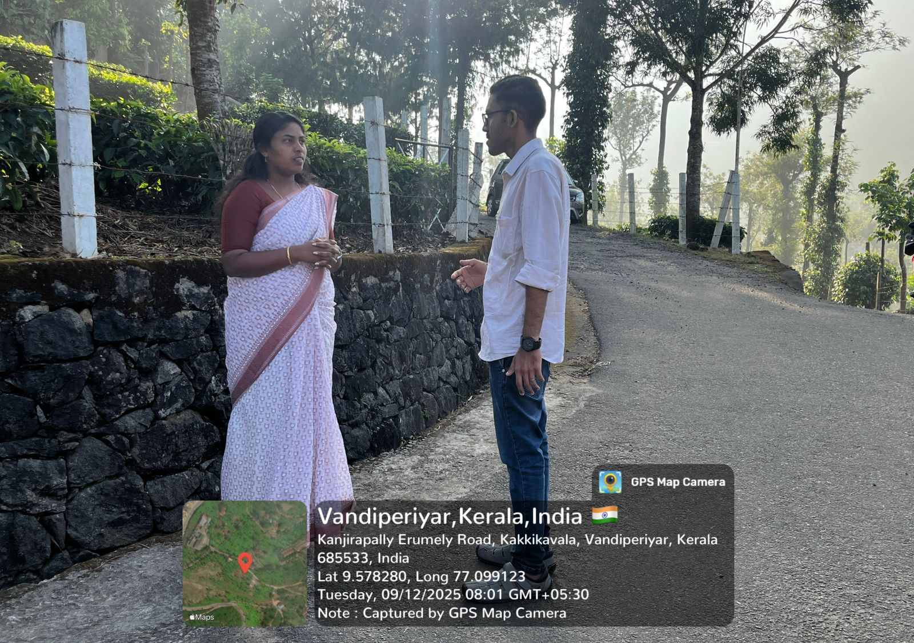

SYSTEM SPECIFICATION

System specification describes the basic hardware and software requirements needed to develop and run the AquaSafe flood monitoring system. It includes the computer configuration required for developing the web application and the technologies used for integrating the IoT devices with the system.

Hardware Specification

Processor - Intel Core i3 or above
RAM - 4 GB
Hard disk - 500 GB

Software Specification

Front End - HTML5, CSS, JavaScript, AJAX, jQuery
Back End - PHP
Database - MySQL
Client on PC - Windows 7 and above.

Technologies used - JavaScript, HTML5, AJAX, jQuery, PHP, CSS, APIs, IoT technologies.

SOFTWARE DESCRIPTION

PHP

PHP is a widely used server-side scripting language designed for web development. It is used to create dynamic and interactive web pages by processing data on the server and sending the results to the user’s browser. PHP is easy to learn, flexible, and integrates well with databases such as MySQL.

In this project, PHP is used as the back-end technology to manage the communication between the web application and the database. It processes the data received from the IoT devices, stores the sensor readings in the database, and retrieves the information to display it on the dashboard. PHP also helps in handling user authentication, managing alerts, and controlling the overall functionality of the system.

MySQL

MySQL is an open source relational database management system used to store, manage, and retrieve data efficiently. It organizes data in the form of tables consisting of rows and columns, which makes data management simple and structured. MySQL is widely used in web applications because it is reliable, fast, and easy to integrate with programming languages such as PHP.

In this project, MySQL is used as the database to store information related to sensor readings, water level status, alert messages, and user details. The data received from the IoT devices is stored in the database and can be accessed by the web application whenever required. This helps in maintaining records of water level data and allows users to monitor the system through the dashboard.

CHAPTER 4

SYSTEM DESIGN

  - INTRODUCTION

In the AquaSafe flood monitoring system, the design includes both hardware and software components. The hardware part consists of water level sensors, an ESP32 microcontroller, and a LoRaWAN communication module. These components work together to detect changes in water levels and transmit the collected data.
The software part includes the web application, database, and dashboard interface. The web application receives data from the IoT devices, processes it, and stores it in the database. The dashboard displays the water level status, alerts, and other related information to users in real time. Through this design, the system ensures continuous monitoring, efficient data processing, and timely alerts to help prevent flood-related risks.

UML DIAGRAM

Unified Modeling Language (UML) diagrams are used to visually represent the structure and behavior of a system. They help in understanding how different components of the system interact with each other and how data flows within the system. UML diagrams provide a clear blueprint of the system before implementation, making it easier to design, develop, and maintain the application.

In the AquaSafe IoT flood monitoring system, UML diagrams are used to illustrate the interaction between users, sensors, servers, and the database. These diagrams show how the system collects water level data, processes it, stores it in the database, and provides alerts and monitoring features through the web application.

4.2.1 USE CASE DIAGRAM

The use case diagram represents the interaction between users and the AquaSafe system. It shows the different functionalities that the system provides to various actors such as the Resident User, Administrator, and IoT Sensors. The diagram includes functions like user login, viewing the flood map, sharing emergency location, acknowledging SOS signals, managing evacuation points, broadcasting alerts, and monitoring sensor health.

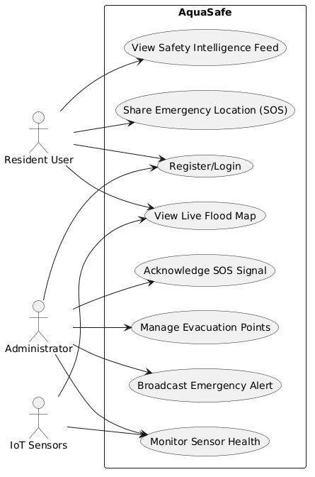

Figure 1: Use Case Diagram

4.2.2 SEQUENCE DIAGRAM

The sequence diagram explains the order of interactions between system components over time. It shows how an administrator acknowledges an SOS signal through the admin dashboard. The request is sent to the server, which updates the emergency status in the MySQL database and sends a response back to the dashboard. The user dashboard then displays a notification indicating that help is on the way.

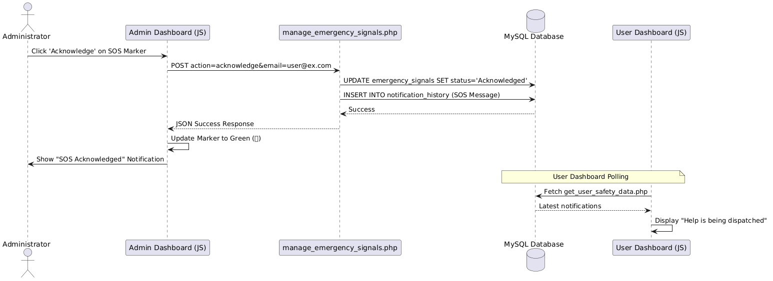

Figure 2: Sequence Diagram

4.2.3 State Chart Diagram

The statechart diagram shows the different states of an SOS emergency signal. It begins when a user shares their location during an emergency. The signal becomes active, and the administrator can acknowledge it. After the rescue is completed or the alert is dismissed, the system moves to the cleared state, indicating that the emergency has been resolved.

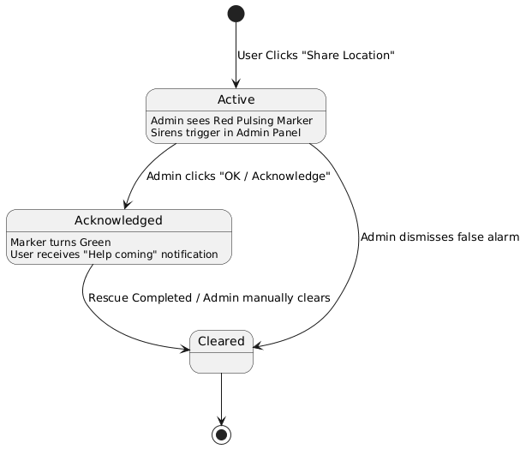
Figure 3: State Chart Diagram

4.2.4 Activity Diagram

The activity diagram represents the workflow of the flood monitoring process. It shows how the IoT sensor sends water level data, which is received by the server. The system then checks whether the water level is within safe limits, warning level, or critical level. Based on this evaluation, alerts are generated and the dashboard is updated accordingly.

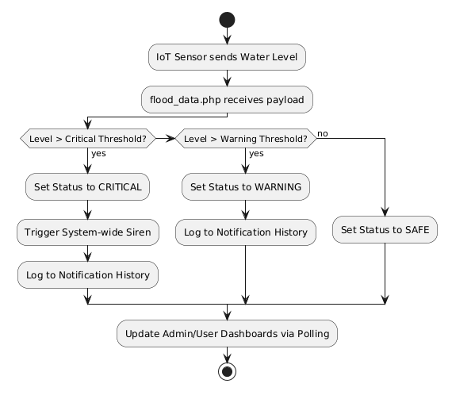
Figure 4: Activity Diagram

4.2.5 Class Diagram

The class diagram represents the structure of the system by showing different classes, their attributes, methods, and relationships. The main classes in the system include User, Sensor, Admin, Emergency Signal, and Notification. These classes interact with each other to manage user actions, sensor data updates, emergency signals, and notification alerts within the system.
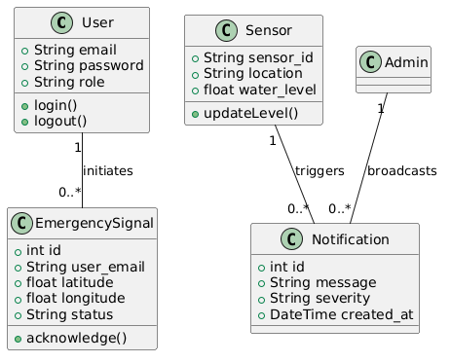

Figure 5: Class Diagram

4.2.6 Object Diagram

The object diagram shows a snapshot of the system at a specific moment. It illustrates real instances of classes such as a resident user, a sensor device, and an emergency signal. This diagram helps in understanding how actual data values like email, sensor ID, water level, and location coordinates exist and interact within the system.

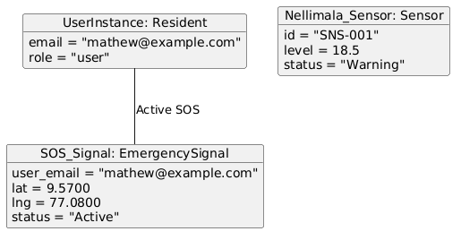

Figure 6: Object Diagram

4.2.7 Component Diagram
The component diagram shows the organization of the software components in the system. It includes the client-side browser interface, server-side modules, and the database. Components such as the user dashboard, admin dashboard, authentication module, emergency manager, and PHP API layer work together to process requests and store data in the MySQL database.

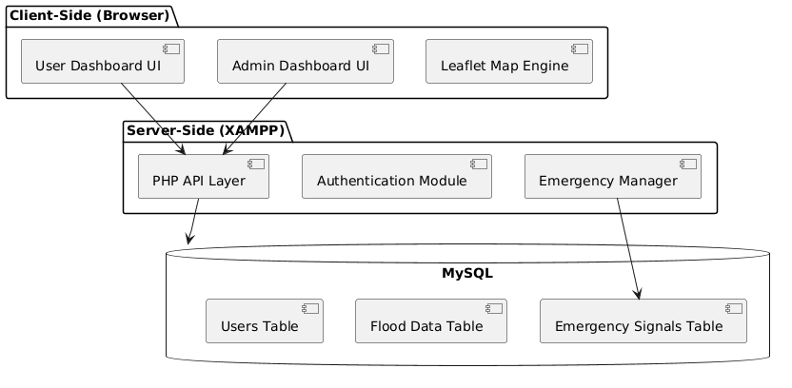

Figure 7: Component Diagram
4.2.8 Deployment Diagram
The deployment diagram illustrates the physical architecture of the system. It shows how hardware devices and software components are deployed across different nodes. The IoT hardware with ESP32 sensors sends telemetry data to the Apache web server, which processes it using the PHP runtime and stores it in the MariaDB/MySQL database. Users access the system through web browsers on computers or mobile devices.
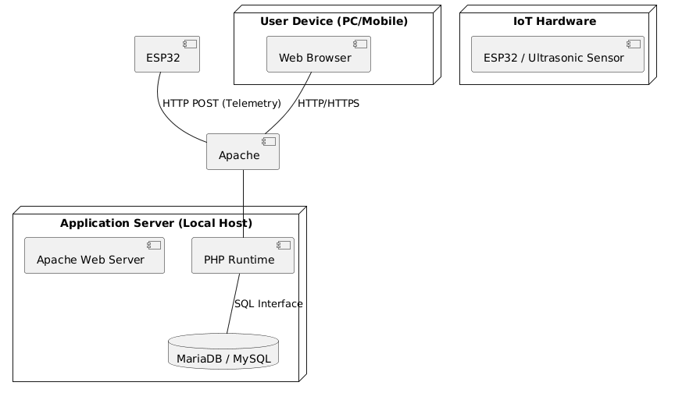

Figure 8: Deployment Diagram

4.2.9 Collaboration Diagram
The collaboration diagram illustrates how different objects communicate and collaborate to complete a specific task. In this system, it shows how the admin interacts with the map interface to acknowledge an emergency signal. The request passes through the emergency logic module, updates the database, and returns a success status to the interface.

Figure 9: Collaboration Diagram

4.3 USER INTERFACE DESIGN USING FIGMA

Form Name: Landing Page
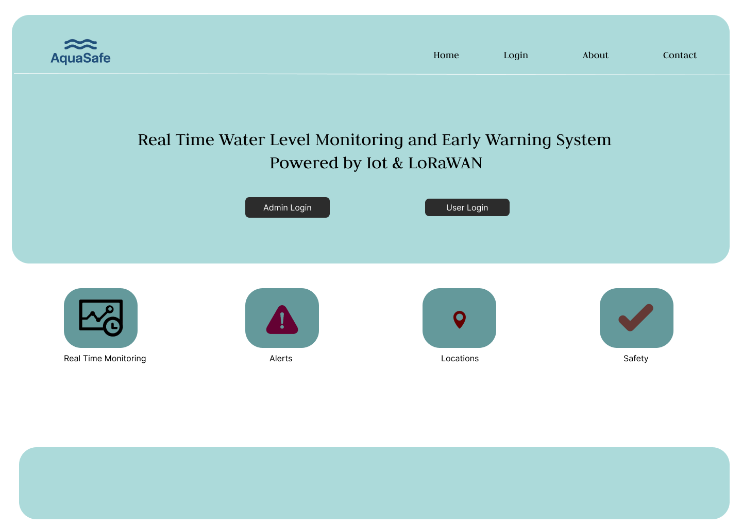

Form Name: Login Page

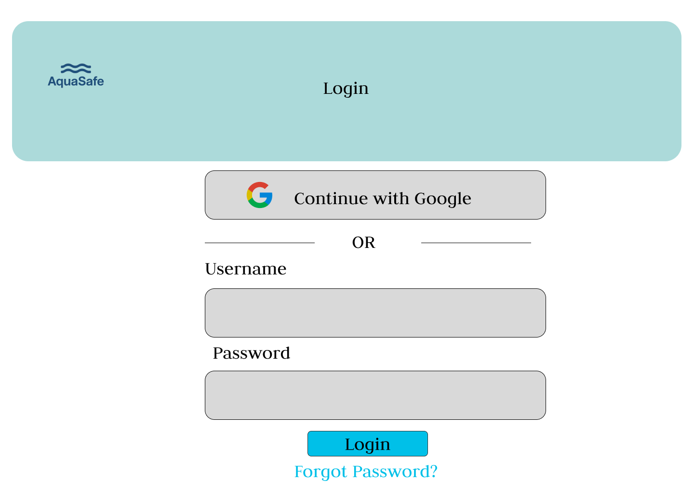

Form Name: Admin Dashboard
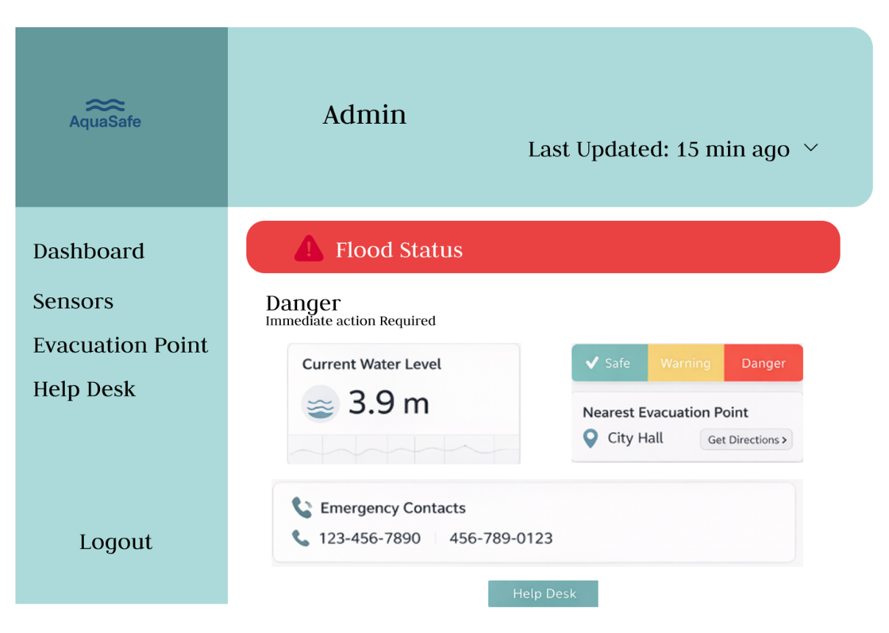

Form Name: User Dashboard
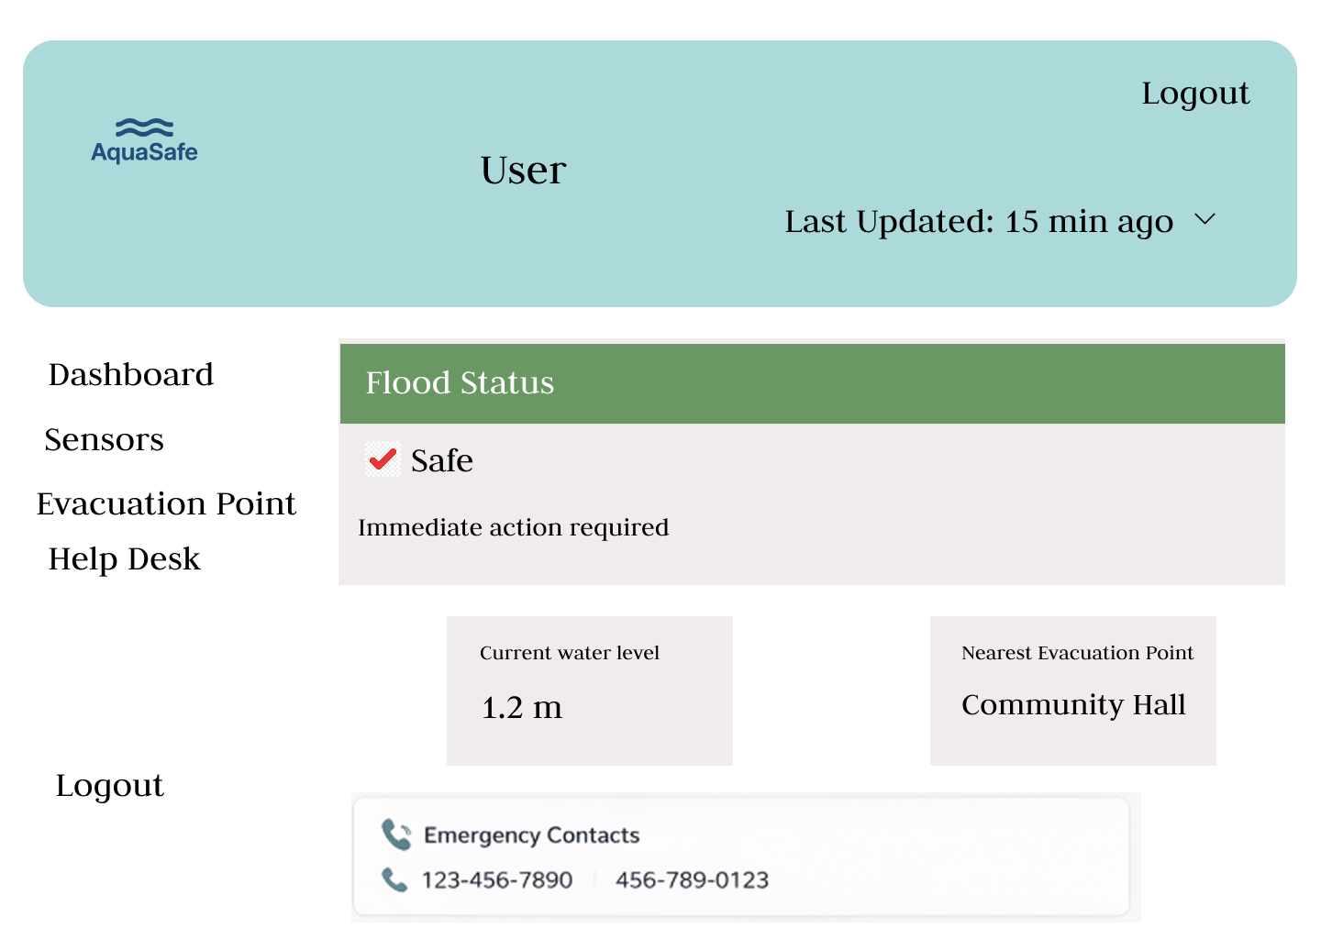

Form Name: Sensor Details
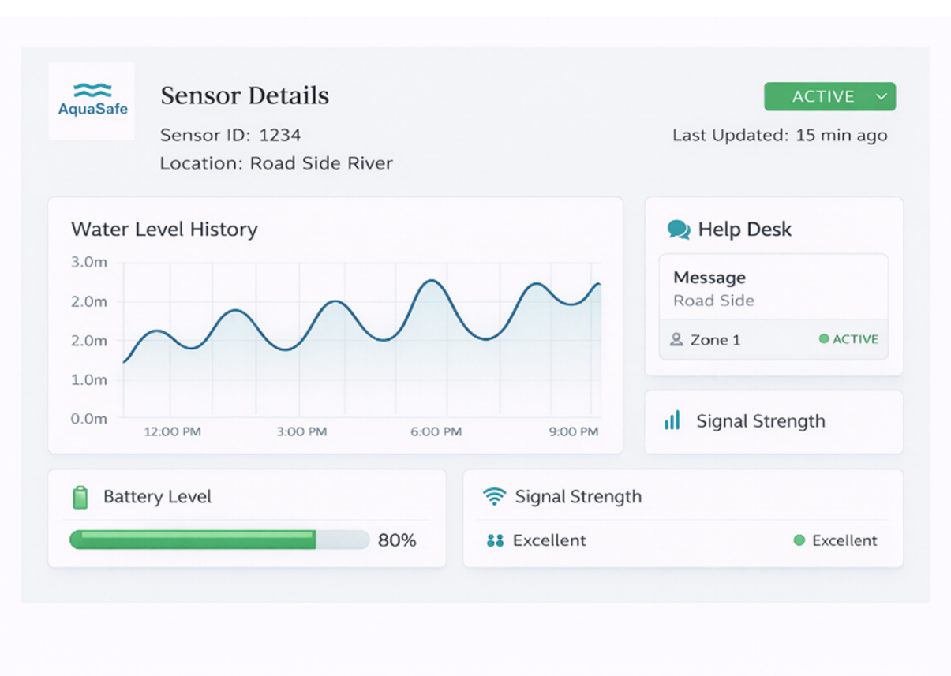

Form Name: Help Desk
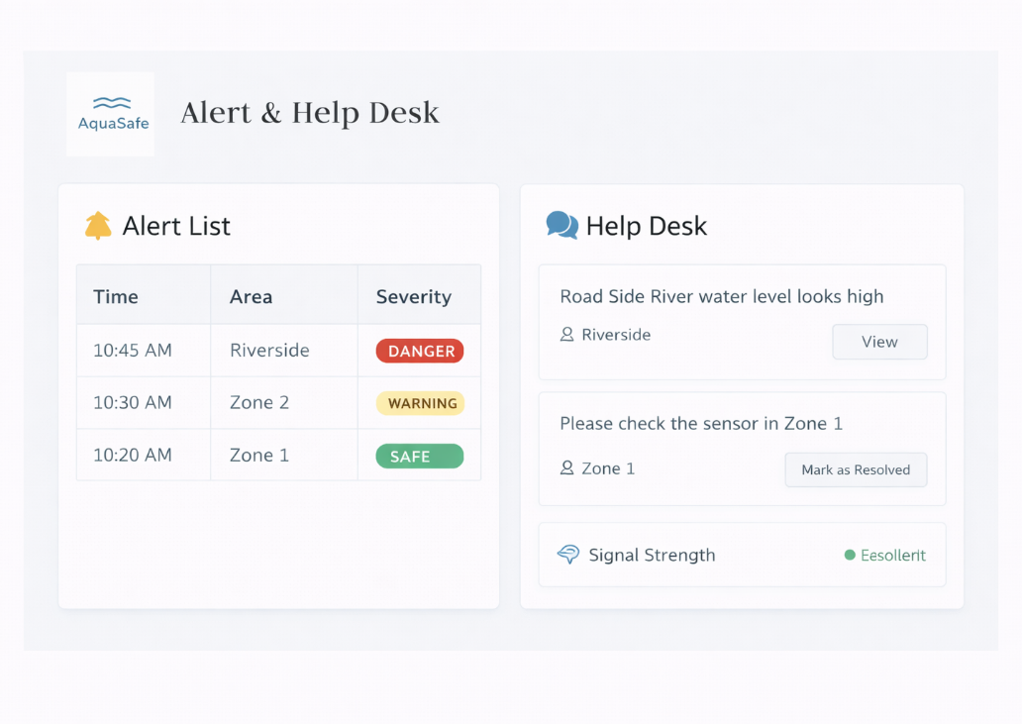

4.4 DATABASE DESIGN

4.4.1 Relational Database Management System (RDBMS)
The AquaSafe system utilizes MariaDB (part of the XAMPP stack) as its Relational Database Management System. An RDBMS is essential for this project because it allows data to be stored in structured tables that are logically linked through relationships. In AquaSafe, the RDBMS handles:
Data Integrity: Ensuring that emergency signals are associated with valid users.
Concurrency: Allowing multiple sensors to upload water level data simultaneously while administrators monitor the dashboard.
Persistence: Storing historical flood data for trend analysis even after system restarts.

4.4.2 Normalization
Normalization is the process of organizing data to reduce redundancy and improve data integrity. In AquaSafe, we follow Third Normal Form (3NF) by splitting data into specialized tables.
Example from AquaSafe: Instead of storing user names and contact details inside every "Emergency Signal" record, we use separate tables:
users Table: Stores unique user information (Email, Password, Name).
emergency_signals Table: Stores only the user_email as a foreign key reference, along with coordinates and status.
This ensures that if a user changes their contact information, we only update it once in the users table, and all related emergency signals remain correctly linked without data duplication.

4.4.3 Sanitization
Data sanitization is a critical security measure to prevent SQL Injection attacks, where malicious users attempt to execute unauthorized commands by injecting code into input fields (e.g., login or SOS forms).
Implementation in AquaSafe: In the PHP backend, we prioritize Prepared Statements and Parameter Binding.
Example: In manage_emergency_signals.php, instead of directly inserting variables into an SQL string, we use the following pattern:

$update_sql = "UPDATE emergency_signals SET status = ? WHERE user_email = ?";
$stmt = mysqli_prepare($link, $update_sql);
mysqli_stmt_bind_param($stmt, "ss", $status, $email);
mysqli_stmt_execute($stmt);

This ensures that the database treats the input strictly as data, never as executable code, effectively sanitizing the input.

4.4.4 Indexing
Indexing is a performance optimization technique used to speed up the retrieval of records. Without indexes, the database must scan every single row (a "full table scan") to find a specific piece of data, which becomes extremely slow as the flood_data table grows into thousands of entries.
Implementation in AquaSafe:
Primary Keys: Every core table (like emergency_signals and flood_data) uses an
id column as a Primary Key. The RDBMS automatically creates a B-Tree index for these keys.
Fast Lookups: When the Admin Dashboard polls for "Active" signals (WHERE status = 'Active'), indexing allows the database to instantly locate those specific rows, providing near-instantaneous live map updates even under heavy data load.

4.5 TABLE DESIGN

- alert_history

Eg. Primary key: id

No: | Field name | Datatype (Size) | Key Constraints | Description of the field
1 | id | int(11) | Primary Key | Unique identifier for alerting history record
2 | sensor_id | int(11) |  | ID of the sensor that triggered the alert
3 | message | text |  | Content of the alert message sent
4 | created_at | timestamp |  | Time identifying when the alert was logged

- community_alerts

Eg. Primary key: id

No: | Field name | Datatype (Size) | Key Constraints | Description of the field
1 | id | int(11) | Primary Key | Unique identifier for community submitted alerts
2 | user_email | varchar(255) |  | Email of the user who submitted the alert
3 | message | text |  | Description of the local flood situation
4 | location | varchar(255) |  | Geographic area or coordinates of the alert
5 | status | varchar(50) |  | Current status (Pending, Verified, Resolved)
6 | created_at | timestamp |  | Timestamp of submission

3. emergency_signals
Eg. Primary key: id
Eg. Foreign key: user_email references table users
No: | Field name | Datatype (Size) | Key Constraints | Description of the field
1 | id | int(11) | Primary Key | Unique identifier for the emergency signal
2 | user_email | varchar(255) | Foreign Key | Email of the user in distress
3 | latitude | decimal(10,8) |  | GPS latitude of the emergency
4 | longitude | decimal(11,8) |  | GPS longitude of the emergency
5 | status | varchar(50) |  | Status of rescue (Active, Acknowledged, Cleared)
6 | created_at | timestamp |  | Time identifying when SOS was shared
7 | updated_at | timestamp |  | Last update time

4. evacuation_points
Eg. Primary key: id

No: | Field name | Datatype (Size) | Key Constraints | Description of the field
1 | id | int(11) | Primary Key | Unique identifier for the evacuation center
2 | name | varchar(255) |  | Name of the evacuation facility
3 | location | varchar(255) |  | Address or landmark of the evacuation point
4 | status | varchar(50) |  | Operational status (Open, Full, Closed)
5 | capacity | int(11) |  | Maximum number of people supported

5. flood_alerts
Eg. Primary key: id

No: | Field name | Datatype (Size) | Key Constraints | Description of the field
1 | id | int(11) | Primary Key | ID for system generated threshold alerts
2 | level | decimal(5,2) |  | Water level at the time of alert
3 | severity | varchar(50) |  | Alert level (Warning, Critical)
4 | created_at | timestamp |  | Time of alert generation

6. flood_data
Eg. Primary key: id
Eg. Foreign key: sensor_id references table sensor_status

No: | Field name | Datatype (Size) | Key Constraints | Description of the field
1 | id | int(11) | Primary Key | Unique ID for telemetry reading
2 | sensor_id | int(11) | Foreign Key | ID of the IoT sensor
3 | level | decimal(5,2) |  | Water level measured in feet
4 | status | varchar(50) |  | Normalized status calculated by server
5 | created_at | timestamp |  | Timestamp of IoT transmission

7. helpdesk_requests
Eg. Primary key: id

No: | Field name | Datatype (Size) | Key Constraints | Description of the field
1 | id | int(11) | Primary Key | Unique ID for user support tickets
2 | user_email | varchar(255) |  | Email of the requesting resident
3 | subject | varchar(255) |  | Title of the support request
4 | message | text |  | Detailed description of the issue
5 | status | varchar(50) |  | Ticket status (Open, In Progress, Resolved)

8. notification_history
Eg. Primary key: id

No: | Field name | Datatype (Size) | Key Constraints | Description of the field
1 | id | int(11) | Primary Key | ID for system wide notification log
2 | location | varchar(255) |  | Target area for the notification
3 | severity | varchar(50) |  | Urgency level of the broadcast
4 | message | text |  | Content of the push/feed message
5 | sensor_id | varchar(50) |  | Originating sensor or system code
6 | created_at | timestamp |  | Time identifying when broadcast occurred

9. sensor_status
Eg. Primary key: sensor_id

No: | Field name | Datatype (Size) | Key Constraints | Description of the field
1 | sensor_id | varchar(50) | Primary Key | Hardware ID of the IoT device
2 | location_name | varchar(255) |  | Human readable location name
3 | role | varchar(50) |  | Device role (Sensor Node, Receiver Hub)
4 | status | varchar(50) |  | Current device health
5 | water_level | decimal(5,2) |  | Last known water level
6 | last_ping | timestamp |  | Last successful heartbeat

10. users
Eg. Primary key: email

No: | Field name | Datatype (Size) | Key Constraints | Description of the field
1 | email | varchar(255) | Primary Key | Unique email used for login
2 | password | varchar(255) |  | Hashed user password
3 | full_name | varchar(255) |  | Name of the resident or admin
4 | role | varchar(50) |  | Access level (Admin, Resident)
5 | location | varchar(255) |  | Registered residential area
6 | status | varchar(50) |  | Account status (Active, Suspended)
7 | reset_token | varchar(255) |  | Token used for password recovery
8 | reset_expiry | datetime |  | Expiry time for reset token
9 | created_at | timestamp |  | Account creation date

CHAPTER 5

SYSTEM TESTING

  - INTRODUCTION
System testing is a critical validation phase in the software development lifecycle designed to evaluate the complete and integrated system’s compliance with its specified requirements. For the AquaSafe platform, ensuring reliability, accuracy, and uninterrupted access is of paramount importance given its role as a real-time flood monitoring and emergency response system.

To achieve a rigorous evaluation of the platform, the testing phase employs End-to-End (E2E) Automated UI Testing using Selenium WebDriver and the Python unit test framework. This approach simulates real-world user interactions within the browser environment, validating both the frontend interfaces and the underlying backend logic in a unified manner.

- Authentication & Access Control (test_01_registration & test_02_login) Validates the integrity of the user onboarding process. This includes verifying form validations, confidentially handling credentials during registration, and confirming accurate role-based redirection to the dashboard upon successful login.
- Dashboard Integrity (test_03_alerts) Ensures that upon successful authentication, the primary safety console loads the latest intelligence elements—including active flood warnings, safe shelter statuses, and the timeline of critical events.
- Emergency Interactivity (test_04_helpdesk) Tests the reliability of out-bound communications, specifically the Help Desk ticketing interface. This guarantees that residents in distress can access the forms necessary to request immediate rescue or assistance.
- User Configuration (test_05_settings) Confirms that user profile configurations, location updates, and general settings are consistently accessible and modifiable by the account holder.
- Session Management (Automated Logout) Across all testing modules, a persistent verification of the "Logout" functionality ensures that active browser sessions are safely terminated, removing sensitive dashboard data from the screen and securing the user's account.
By utilizing automated E2E tests for these core features, we guarantee that AquaSafe's critical communication and safety mechanisms function flawlessly under simulated real-world conditions before deployment.

TEST PLAN

The testing process for the AquaSafe web application focuses on verifying the correct functioning of essential system features such as user authentication and dashboard operations. Automated End-to-End testing is performed using the Python unit test framework together with Selenium WebDriver to simulate real user interactions through a web browser. The tests are executed in a controlled environment using a local PHP server and MySQL database to ensure accurate evaluation of the system’s behavior.

The test suite includes multiple test cases covering important functionalities such as user registration, login authentication, navigation to the alerts section, access to the emergency help desk, and modification of user profile settings. Each test checks whether the application responds correctly by validating page loads, UI elements, and proper URL redirection.

The results of these tests help confirm that the system performs reliably and that the user interface operates as expected. Any errors detected during testing are logged and can be used to improve the overall stability and performance of the AquaSafe application.

Unit Testing

Unit testing is the initial level of testing carried out in the AquaSafe project to verify the correctness of individual components and functions before they are integrated into the complete system. The main aim is to ensure that each module of the application works properly when tested independently.

In the AquaSafe system, unit testing mainly focuses on backend PHP scripts and database operations. Important areas tested include user authentication and validation during registration, database queries used to retrieve system data, and session management functions that control user access to protected dashboard pages. The tests also check how the system handles incorrect inputs or unexpected conditions to ensure proper error handling.

By performing unit testing at an early stage, logical errors can be detected and corrected quickly. This helps improve system reliability and reduces difficulties during later stages such as integration testing and system testing.

Integration Testing
Integration testing is the second stage of the testing process in the AquaSafe project. While unit testing checks individual components separately, integration testing focuses on verifying how different modules of the system interact with each other. Since the AquaSafe platform depends on communication between the front-end interface, backend PHP scripts, and the MySQL database, testing these interactions is essential for ensuring proper system operation.
In this phase, tests are performed to confirm that data is correctly transferred between the user interface and backend processing scripts, and that database operations such as creating, retrieving, updating, and deleting records work correctly. The testing also verifies that user sessions are properly maintained when users move between different pages of the application. Additionally, the integration with external services such as Google Sign-In is tested to ensure that authentication tokens are correctly processed and user sessions are created successfully.
Through integration testing, the development team ensures that the various components of the AquaSafe system work together smoothly and that data remains secure and consistent throughout the system.

Validation Testing or System Testing
Validation testing, also known as system testing, is the final stage of the testing process carried out before the deployment of the AquaSafe platform. At this stage, the entire system is tested as a complete unit to ensure that it meets the specified requirements and performs correctly in real-world situations. The purpose of this testing is to verify that all features of the system work together effectively to provide reliable flood monitoring and emergency response services to users.
For the AquaSafe project, validation testing is performed using Automated End-to-End (E2E) testing with Selenium WebDriver and Python’s unittest framework. These automated tests simulate real user actions in the Google Chrome browser, such as registering a new account, logging into the system, navigating through the dashboard, checking safety alerts, submitting help desk requests, and updating profile settings.
The tests verify that each workflow functions correctly, including successful user registration, secure authentication, proper loading of dashboard features, and safe session termination through logout. By executing these automated system tests, the AquaSafe platform ensures that all system components work together properly and that the application is reliable and ready for deployment.

Output Testing or User Acceptance Testing
User Acceptance Testing (UAT) is the final stage of the testing process conducted before the AquaSafe system is fully deployed. The purpose of this testing is to ensure that the application meets the needs and expectations of its actual users, such as local residents and emergency management administrators. Unlike other testing stages that focus on technical functionality, UAT evaluates the system from the user’s perspective to confirm that it is practical, understandable, and easy to use.
During UAT, users test the main features of the AquaSafe platform, including the resident dashboard, safety alerts, emergency help desk tools, and administrative controls. The testing verifies that important information such as water level status, safety warnings, and evacuation guidance is clearly displayed and easy to understand. It also checks whether emergency tools like help desk requests and SOS features work properly and provide clear confirmation to users.
Additionally, the system is tested on different devices to ensure that it works correctly on desktops, tablets, and mobile phones. Successful completion of User Acceptance Testing confirms that the AquaSafe system is not only technically functional but also effective and user-friendly for real-world emergency monitoring and communication.

    - Automation Testing
Automation testing plays an important role in the quality assurance process of the AquaSafe project. It allows the system to be tested quickly, consistently, and repeatedly without relying on manual testing. Since AquaSafe is designed as an emergency monitoring platform, automated testing helps ensure that important features continue to function correctly whenever updates or changes are made to the system.
In this project, automation testing is performed using Selenium WebDriver with Python’s unittest framework. This setup automatically controls the Google Chrome browser and simulates real user interactions with the web application. Through these automated scripts, both the user interface and backend functionalities are verified.
The testing framework follows a modular structure, where a base configuration file manages the browser setup and common testing functions. Separate scripts are created for different system features such as user registration, login authentication, viewing alerts, accessing the help desk, and managing profile settings. The tests also use synchronization techniques to wait for web elements to load properly, ensuring stable and accurate results.

Additionally, the automation suite captures screenshots during test execution to provide visual evidence of the system’s behavior. By using automated testing, the AquaSafe project ensures that essential features such as emergency alerts, secure authentication, and support services remain reliable and free from major errors.

    - Selenium Testing
Selenium WebDriver is used in the AquaSafe project to perform automated user interface and End-to-End (E2E) testing of the web application. It allows test scripts to simulate real user actions such as clicking buttons, entering data into forms, and navigating through web pages. This helps ensure that the application behaves correctly and that all features work as expected.
In the AquaSafe platform, Selenium is implemented using Python together with the unittest framework, which provides structured test execution and clear error reporting. The automated tests run in the Google Chrome browser using WebDriver. Through Selenium, the scripts interact with the web application by locating HTML elements using identifiers such as IDs, names, or XPath and performing actions like filling registration forms or logging into the system.
The testing scripts also use synchronization methods to wait for page elements to load properly before performing actions, which helps avoid failures caused by slow network responses. Screenshots are automatically captured during testing to provide visual evidence of system behavior. The test suite covers key system functions such as user registration, login authentication, viewing safety alerts, accessing the help desk, and updating user profile settings.
By using Selenium-based automation testing, the AquaSafe system ensures that its important emergency monitoring and communication features remain reliable and function correctly for users.

Test Case 1
Code:
from base_test import AquaSafeBaseTest
from selenium.webdriver.support.ui import WebDriverWait
from selenium.webdriver.support import expected_conditions as EC
from selenium.webdriver.common.by import By
import unittest

class TestRegistration(AquaSafeBaseTest):
def test_signup(self):
print(f"\n[Test] Registration - Email: {self.test_email}")
self.driver.get(f"{self.base_url}/Login/signup.php?role=user")

WebDriverWait(self.driver, 10).until(EC.presence_of_element_located((By.NAME, "signup_btn")))

self.driver.find_element(By.NAME, "name").send_keys("Test User")
self.driver.find_element(By.NAME, "email").send_keys(self.test_email)
self.driver.find_element(By.NAME, "password").send_keys(self.test_password)
self.driver.find_element(By.NAME, "confirm_password").send_keys(self.test_password)
self.driver.find_element(By.NAME, "signup_btn").click()

WebDriverWait(self.driver, 10).until(EC.url_contains("login.php"))
self.assertIn("signup=success", self.driver.current_url)
self.save_screenshot("modular_signup_success")
print("Registration Successful! Now logging in to verify and logout.")

# Verify login and logout
self.login_manually(self.test_email, self.test_password)
WebDriverWait(self.driver, 10).until(EC.url_contains("dashboard"))
self.logout()

if __name__ == "__main__":
unittest.main()
Screenshot
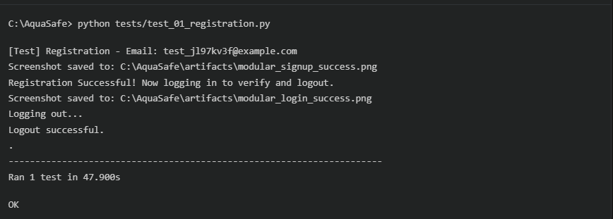

Test Report

Test Case 1
Project Name: AquaSafe
Registration Test Case
Test Case ID: Test_1 |  |  | Test Designed By:
Test Priority(Low/Medium/High):High |  |  | Test Designed Date: March 09, 2026
Module Name: |  |  | Test Executed By :
Test Title : Registration Validation |  |  | Test Execution Date: March 09, 2026
Description: Verify that a new resident can successfully register using valid credentials.
Pre-Condition : The user must not already have an account with the provided email address. The database server must be running.
Step | Test Step | Test Data | Expected Result | Actual Result | Status(Pass/  Fai l)
1 | Navigate to signup.php | URL | Registration page loads. . | Registration page loaded successfully | Pass
2 | Enter Full Name | "Test User" | Name,  email,  password field populated. | Name,  email,  password field populated. | Pass
3 | Enter Email | test1@example.com
4 | Enter Password & Confirm | Password123!
5 | Click "Sign Up" button | N/A | Form submits data to backend. | Form submitted.
 |  |  | Redirects to login.php with success message in URL. Application logged out securely. | Redirected to login with signup=success. | Pass
6 | System Verification | N/A
7 | Session Teardown | N/A |  | Session safely terminated.
Post-Condition: A new user record exists in the Database, and the user is redirected to the Login page.

Test Case 2:
Code
from base_test import AquaSafeBaseTest
from selenium.webdriver.support.ui import WebDriverWait
from selenium.webdriver.support import expected_conditions as EC
from selenium.webdriver.common.by import By
import unittest

class TestLogin(AquaSafeBaseTest):
def test_login(self):
# We assume the user exists from previous test or create one
print(f"\n[Test] Login - Email: {self.test_email}")

# In modular tests, we might need a fresh registration if running in isolation
# but for this flow we can just login with the class-level email
self.login_manually(self.test_email, self.test_password)

WebDriverWait(self.driver, 20).until(
lambda d: "user_dashboard.php" in d.current_url or "dashboard_selector.php" in d.current_url
)
self.save_screenshot("modular_login_success")
self.assertTrue("dashboard" in self.driver.current_url or "selector" in self.driver.current_url)
print(f"Login Successful! Dashboard reached.")
self.logout()

if __name__ == "__main__":
unittest.main()
Screenshot
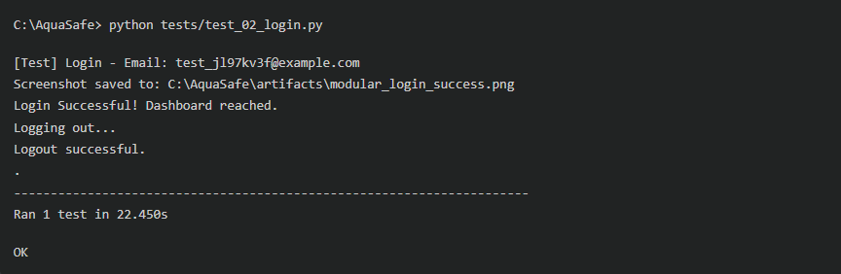
Test report
Test Case 2
Project Name: AquaSafe
Login Test Case
Test Case ID: Test_2 |  |  | Test Designed By:
Test Priority(Low/Medium/High):High |  |  | Test Designed Date: March 09, 2026
Module Name: |  |  | Test Executed By :
Test Title : Login & Dashboard Access |  |  | Test Execution Date: March 09, 2026
Description: Verify that a registered user can log in and successfully access the secure Resident Dashboard.
Pre-Condition : The user must have a valid, active account in the AquaSafe database
Step | Test Step | Test Data | Expected Result | Actual Result | Status(Pass/  Fai l)
1 | Navigate to login.php | URL | Login page loads. . | Registration page loaded successfully | Pass
2 | Enter Email | test1@example.com | Email,password field populated. Form submits data. | Email,password field populated. Form submits data. | Pass
3 | Enter Password & Confirm | Password123!
4 | Click "Login" button | N/A
5 | Dashboard Routing | N/A | Form submits data to backend. | Form submitted.
 |  |  | Redirects to login.php with success message in URL. Application logged out securely. | Redirected properly to dashboard URL. | Pass
6 | System Verification | N/A
7 | Click "Sign Out" | N/A |  | Session cleared, redirected to login.
Post-Condition: An active PHP session is temporarily generated and then correctly destroyed upon logout.

Test Case 2:
Code
from base_test import AquaSafeBaseTest
from selenium.webdriver.support.ui import WebDriverWait
from selenium.webdriver.support import expected_conditions as EC
from selenium.webdriver.common.by import By
import unittest
import time

class TestAlerts(AquaSafeBaseTest):
def test_view_alerts(self):
print("\n[Test] View Alerts")
# Ensure logged in (using the same class-level test account)
# Note: If running this file standalone, it might fail if user doesn't exist
# Better practice for E2E: Login first
self.login_manually(self.test_email, self.test_password)

# Click Alerts in Sidebar
self.navigate_to_sidebar("section-alerts")

self.save_screenshot("feature_alerts_view")
print("Alerts section verified!")
self.logout()

if __name__ == "__main__":
unittest.main()

Screenshot
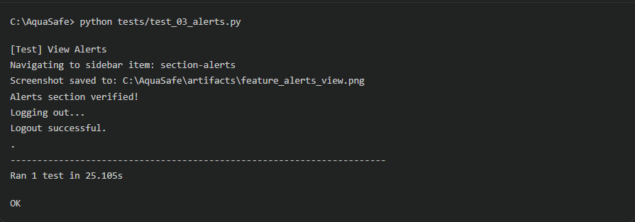

Test report
Test Case 3
Project Name: AquaSafe
Alert Test Case
Test Case ID: Test_3 |  |  | Test Designed By:
Test Priority(Low/Medium/High):High |  |  | Test Designed Date: March 09, 2026
Module Name: |  |  | Test Executed By :
Test Title : View Alerts Board |  |  | Test Execution Date: March 09, 2026
Description: Verify that the Safety Intelligence Terminal (Alerts) successfully renders when navigated to.
Pre-Condition: User must be successfully logged into the AquaSafe dashboard. database
Step | Test Step | Test Data | Expected Result | Actual Result | Status(Pass/  Fai l)
1 | Locate Sidebar | N/A | Sidebar menu is visible. | Registration page loaded successfully | Pass
2 | Click "Alerts" link | Target: section-alerts | System processes click interaction.  The #section-alerts div becomes active/visible.  System clears session. | Element clicked successfully.  Section loaded into DOM.  Session safely terminated. | Pass
3 | Load Alerts Panel | N/A
4 | Log Out | N/A
Post-Condition: The Alerts UI is active, displaying the most recent broadcast data.

Test Case 4:
Code
from base_test import AquaSafeBaseTest
from selenium.webdriver.support.ui import WebDriverWait
from selenium.webdriver.support import expected_conditions as EC
from selenium.webdriver.common.by import By
import unittest

class TestHelpDesk(AquaSafeBaseTest):
def test_submit_help_request(self):
print("\n[Test] Submit Help Desk Request")
self.login_manually(self.test_email, self.test_password)

# Click Help Desk
self.navigate_to_sidebar("section-help")

# Verify Help Desk section
WebDriverWait(self.driver, 10).until(EC.presence_of_element_located((By.ID, "section-help")))

# Check if form exists
try:
form = self.driver.find_element(By.ID, "helpdeskForm")
self.assertTrue(form.is_displayed())
print("Help Desk form found!")
except:
print("Looking for submit button or similar in Help Desk...")

self.save_screenshot("feature_helpdesk_view")
print("Help Desk functionality verified!")
self.logout()

if __name__ == "__main__":
unittest.main()

Screenshot
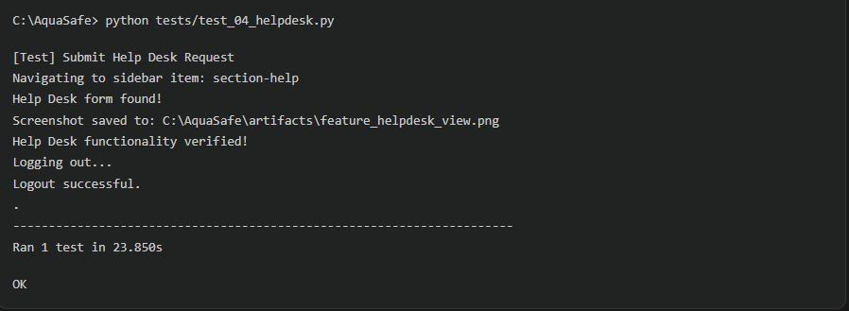

Test Report

Test Case 4
Project Name: AquaSafe
Helpdesk Test Case
Test Case ID: Test_4 |  |  | Test Designed By:
Test Priority(Low/Medium/High):High |  |  | Test Designed Date: March 09, 2026
Module Name: |  |  | Test Executed By :
Test Title : Help Desk Navigation |  |  | Test Execution Date: March 09, 2026
Description: Verify the user can interact with the sidebar to access the emergency Help Desk forms.
Pre-Condition: User must be successfully logged into the AquaSafe dashboard.
Step | Test Step | Test Data | Expected Result | Actual Result | Status(Pass/  Fai l)
1 | Locate Sidebar | N/A | Sidebar menu is visible. | Sidebar rendered on screen. | Pass
2 | Click "Help Desk" | Target: section-alerts | System processes click interaction.  The #section-alerts div becomes active/visible.  System clears session. | Element clicked successfully. Ticketing form found and visible.  Session safely terminated. | Pass
3 | Locate Support Form | ID: helpdeskForm
4 | Log Out | N/A
Post-Condition: User is on the Help Desk interface, ready to submit an emergency rescue request.

Test Case 5:
Code
from base_test import AquaSafeBaseTest
from selenium.webdriver.support.ui import WebDriverWait
from selenium.webdriver.support import expected_conditions as EC
from selenium.webdriver.common.by import By
import unittest

class TestSettings(AquaSafeBaseTest):
def test_profile_access(self):
print("\n[Test] Profile/Settings Access")
self.login_manually(self.test_email, self.test_password)

# Click Settings
self.navigate_to_sidebar("section-settings")

# Check for profile name input or similar
body_text = self.driver.find_element(By.TAG_NAME, "body").text
self.assertIn("Settings", body_text)

self.save_screenshot("feature_settings_view")
print("Settings section verified!")
self.logout()

if __name__ == "__main__":
unittest.main()

Screenshot

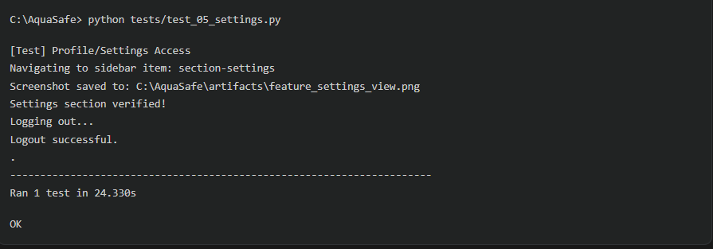

TestReport
Test Case 5
Project Name: AquaSafe
Helpdesk Test Case
Test Case ID: Test_4 |  |  | Test Designed By:
Test Priority(Low/Medium/High):Medium |  |  | Test Designed Date: March 09, 2026
Module Name: |  |  | Test Executed By :
Test Title : Settings & Profile UI |  |  | Test Execution Date: March 09, 2026
Description: Verify that the Settings section becomes active and editable when selected by the user.
Pre-Condition: User must be successfully logged into the AquaSafe dashboard.
Step | Test Step | Test Data | Expected Result | Actual Result | Status(Pass/  Fai l)
1 | Locate Sidebar | N/A | Sidebar menu is visible. | Sidebar rendered on screen. | Pass
2 | Click "Settings" | Target: section-settings | System processes click interaction.  Profile forms and location settings load.becomes active/visible.  System clears session. | Element clicked successfully. Settings text found in document body.  Session safely terminated. | Pass
3 | Verify Tab Content | Text: "Settings"
4 | Log Out | N/A
Post-Condition: User is interacting with the configuration menus successfully.

CHAPTER 6

IMPLEMENTATION

INTRODUCTION

The implementation phase of the AquaSafe project involves the transition of the system from a development environment (XAMPP/Localhost) to a live production environment. This phase ensures that the software, database, and hardware integrations (IoT sensors) are properly configured to work in a real-world scenario. The primary goal of implementation is to provide a stable, secure, and accessible platform for users to monitor water levels and manage flood alerts in real-time.

IMPLEMENTATION PROCEDURES

The implementation process followed a systematic approach to ensure all components were synchronized:
- Environment Preparation: Setting up the cloud infrastructure and database servers.
- Database Migration: Exporting the local MySQL schema and importing it into the cloud-hosted MySQL Flexible Server.
- Code Deployment: Transferring PHP files, assets (CSS/JS), and logic modules to the web server.
- Security Configuration: Implementing SSL/HTTPS for data encryption and configuring SMTP for secure email alerts.
- Final Integration: Linking the IoT hardware endpoints to the web application’s data receiving scripts.

User Training
The successful implementation of AquaSafe depends on the users' ability to interact with the system effectively. Training was conducted for two primary groups:
A. Administrator Training: Administrators were trained on the "Admin Dashboard" to monitor live water levels across different zones. They were instructed on the "Emergency Response" module, specifically how to update evacuation status and manage help desk tickets submitted by users.
B. Public User Training: Training session for general users focused on web accessibility. Users were guided on how to register an account, interpret the dynamic visualizations of water levels, and receive real-time notifications on their devices. Special emphasis was placed on the "Sign in with Google" feature to ensure a low barrier to entry for all citizens.
C. System Handover: Technical documentation and training were provided to the maintenance team regarding the Azure cloud environment, ensuring they can perform basic troubleshooting of the PHP logic and database connectivity.

Training on the Application Software
Users are provided with a comprehensive walkthrough to ensure they can effectively utilize AquaSafe:
- Dashboard Navigation: Training on how to interpret real-time water level charts and environmental alerts.
- Authentication Flow: Guidance on the standard signup/login process and the use of "Sign in with Google" for simplified access.
- Response Management: Instructions for administrators on how to handle Help Desk requests and manage evacuation points during a flood event.
- Mobile Responsiveness: Demonstrating how the glassmorphism UI adapts to mobile devices for on-the-go monitoring.

System Maintenance

To ensure the long-term reliability of AquaSafe, the following maintenance procedures are established:

Routine Backups: Automated daily backups of the MySQL database are configured via Azure's backup policy to prevent data loss.

Security Audits: Regular verification of SSL certificates and API keys (Google OAuth, Gmail App Passwords) to maintain project integrity.

Performance Monitoring: Monitoring server response times and database query efficiency to ensure real-time data remains accurate.

Code Updates: Modular architecture allows for seamless updates to specific features (like the Alert system) without interrupting the entire service.

    - Hosting
While many free platforms like 000Webhost exist, AquaSafe is hosted on Microsoft Azure for enterprise-grade stability, SSL security, and robust database management.

MICROSOFT AZURE
For the final, production-ready version of AquaSafe, Microsoft Azure was selected as the primary cloud infrastructure provider. Azure offers enterprise-grade security, high availability, and superior processing power compared to free hosting services. By utilizing Azure App Service and Azure Database for MySQL Flexible Server, the project achieved professional-level data encryption (SSL/TLS) and reliable up-time for critical flood monitoring. Azure’s robust networking also allows for seamless communication between the cloud-hosted back-end and the physical IoT sensors (ESP32).

Procedure for hosting the website on Azure:
- Step 1: Resource Creation: Create an "App Service" (Web App) in the Azure Portal with a PHP 8.x runtime.
- Step 2: Database Setup: Provision an "Azure Database for MySQL Flexible Server" and configure firewall rules to allow access from the Web App.
- Step 3: File Deployment: Use the "Advanced Tools (Kudu)" or FTP to upload the wwwroot files from the local XAMPP environment to the Azure file system.
- Step 4: Configuration: Update
config.php and
config_secrets.php with the Azure Database connection strings and SMTP credentials for email delivery.
- Step 5: SSL Activation: Enable HTTPS to ensure all user data and login credentials are encrypted during transmission.

Hosted Website:
HostedLink: https://aquasafe-app-gqhxdpeac4epgmhy.eastasia-01.azurewebsites.net/
Hosted Link QR Code
Screenshot

CHAPTER 7

CONCLUSION AND FUTURE SCOPE

CONCLUSION

The development and implementation of the AquaSafe platform highlight the importance of using modern web technologies and real-time communication systems to address the challenges posed by natural disasters such as floods. The system provides a reliable platform that connects emergency management authorities with residents, allowing important information to be shared quickly and effectively during critical situations.

By using technologies such as PHP, MySQL, and JavaScript, the AquaSafe platform offers important features including real-time flood status updates, evacuation guidance, and an SOS help request system. These features help users receive timely information and support during emergency situations. The system also includes secure authentication mechanisms to protect both administrative controls and user data.

In addition, the use of automated testing ensures that the platform functions reliably and that all key components operate correctly. Overall, the AquaSafe system meets its main goal of improving communication, providing early warnings, and supporting faster response during flood emergencies, thereby contributing to the safety and preparedness of the community.
.
  - FUTURE SCOPE

While the current iteration of AquaSafe provides a comprehensive suite of emergency management tools, there is significant potential to expand the platform’s capabilities to further enhance community resilience and predictive accuracy.

Key areas for future development and system expansion include:
IoT Sensor Integration & Automation: The platform can be integrated directly with physical IoT water-level sensors (e.g., ultrasonic or hydrostatic sensors placed in rivers and drainage systems). This would allow AquaSafe to transition from administrative-input alerts to fully automated, real-time data streaming, triggering predictive warnings before human observation is required.
Machine Learning Predictive Modeling: By aggregating historical flood data and integrating meteorological APIs, future versions of AquaSafe could utilize machine learning algorithms to predict flood trajectories. This predictive modeling would allow the system to automatically calculate the estimated time until floodwaters reach specific community zones, enabling proactive evacuations.
Multi-Channel Notification Systems: To ensure alerts reach residents even when they are not actively logged into the dashboard, future development should include an automated push notification service. This encompasses integrating SMS gateways (like Twilio), automated voice calls for highest-severity alerts, and native mobile application push notifications.
Offline and Low-Bandwidth Capabilities: Recognizing that severe storms often disrupt local internet infrastructure, future scope includes developing a Progressive Web App (PWA) architecture. This would allow residents to access cached evacuation maps, emergency survival guides, and offline communication protocols (such as mesh network or LoRa integration) even during widespread power outages.

CHAPTER 8

BIBLIOGRAPHY

REFERENCES:

- PHP Documentation Group. (n.d.). PHP: Hypertext Preprocessor Manual. Retrieved from: https://www.php.net/manual/en/
- Oracle Corporation. (n.d.). MySQL 8.0 Reference Manual. Retrieved from: https://dev.mysql.com/doc/refman/8.0/en/
- Mozilla Developer Network (MDN). (n.d.). Web Technology for Developers (HTML, CSS, JavaScript). Retrieved from: https://developer.mozilla.org/
- Selenium Project. (n.d.). Selenium WebDriver Documentation. Retrieved from: https://www.selenium.dev/documentation/webdriver/
- Python Software Foundation. (n.d.). unittest — Unit testing framework. Retrieved from: https://docs.python.org/3/library/unittest.html
- Duckett, J. (2014). JavaScript and JQuery: Interactive Front-End Web Development. Wiley.
- Nixon, R. (2021). Learning PHP, MySQL & JavaScript: With jQuery, CSS & HTML5 (6th ed.). O'Reilly Media.

WEBSITES:

- Leaflet JS: Open-source JavaScript library for mobile-friendly interactive maps.
  - Website: https://leafletjs.com/
- Chart.js: Simple, flexible JavaScript charting for designers and developers.
  - Website: https://www.chartjs.org/
- SweetAlert2: A beautiful, responsive, customizable replacement for JavaScript's popup boxes.
  - Website: https://sweetalert2.github.io/
- W3Schools: Global hub for web development tutorials and syntax references.
  - Website: https://www.w3schools.com/
- Apache Friends (XAMPP): Local server environment for PHP and MySQL development.
  - Website: https://www.apachefriends.org/
- Lucide Icons: Open-source library providing beautiful & consistent UI icons.
  - Website: https://lucide.dev/
- Stack Overflow: Community forum for developers to learn and share programming knowledge.
  - Website: https://stackoverflow.com/

CHAPTER 9

APPENDIX

Sample Code
Appendix A: Real-Time Safety Dashboard Interface
<!-- Snippet from user_dashboard.php: Hero Safety Card & Interactive Map Layout -->
<div id="section-flood" class="content-section active">
<!-- Hero Safety Card -->
<div class="hero-card animate__animated animate__fadeIn">
<div style="display: flex; justify-content: space-between; align-items: flex-start; gap: 20px;">
<div>
<div class="safety-badge badge-safe" id="heroBadge">
<i data-lucide="shield-check"></i> <span>Safety Status: Safe</span>
</div>
<h2 style="font-size: 42px; font-weight: 800; color: #fff;" id="heroLevel">-- ft</h2>
<div style="color: var(--teal-accent); font-size: 14px; font-weight: 600;" id="heroLocation">
<i data-lucide="map-pin"></i> Central City Zone
</div>
</div>
<div style="text-align: right; min-width: 120px;">
<div id="heroTrend" style="font-size: 18px; font-weight: 700; color: var(--safe);">--</div>
<div style="width: 100px; height: 30px; margin: 5px 0;">
<canvas id="miniFloodChart"></canvas>
</div>
</div>
</div>
</div>
</div>

Appendix B: Secure User Authentication (PHP/MySQL)
// Snippet from login_process.php: Secure Authentication Logic
<?php
session_start();
require_once "config.php";

if($_SERVER["REQUEST_METHOD"] == "POST"){
$email = trim($_POST["email"]);
$password = trim($_POST["password"]);

// Prepare a select statement to prevent SQL Injection
$sql = "SELECT id, name, email, password, role FROM users WHERE email = ?";

if($stmt = mysqli_prepare($link, $sql)){
mysqli_stmt_bind_param($stmt, "s", $param_email);
$param_email = $email;

if(mysqli_stmt_execute($stmt)){
mysqli_stmt_store_result($stmt);

// Check if email exists, if yes then verify password
if(mysqli_stmt_num_rows($stmt) == 1){
mysqli_stmt_bind_result($stmt, $id, $name, $email, $hashed_password, $role);
if(mysqli_stmt_fetch($stmt)){
if(password_verify($password, $hashed_password)){
// Password is correct, start a new session
$_SESSION["loggedin"] = true;
$_SESSION["id"] = $id;
$_SESSION["email"] = $email;
$_SESSION["name"] = $name;
$_SESSION["role"] = $role;

// Role-based redirection
if ($role === 'admin') {
header("location: admin_dashboard.php");
} else {
header("location: dashboard_selector.php");
}
}
}
}
}
mysqli_stmt_close($stmt);
}
}
?>

Appendix C: IoT Hardware Data Ingestion (PHP/MySQL)
// Snippet from receive_iot_data.php: Handling remote sensor payloads
<?php
// Set headers to accept cross-origin POST requests from IoT hardware
header("Access-Control-Allow-Origin: *");
header("Content-Type: application/json; charset=UTF-8");

require_once 'config.php';

// Verify the request method is POST
if ($_SERVER['REQUEST_METHOD'] === 'POST') {

// Retrieve the raw JSON payload sent by the ESP32
$jsonPost = file_get_contents('php://input');
$data = json_decode($jsonPost, true);

// Validate that the required sensor data arrays are present
if (isset($data['sensor_id']) && isset($data['water_level']) && isset($data['status'])) {

$sensor_id = trim($data['sensor_id']);
$water_level = floatval($data['water_level']);
$status = trim($data['status']); // e.g., "Safe", "Warning", "Danger"

// Prepare the SQL statement to insert the real-time telemetry
$sql = "INSERT INTO flood_data (sensor_id, water_level, status, timestamp)
VALUES (?, ?, ?, NOW())";

if ($stmt = mysqli_prepare($link, $sql)) {
// Bind the incoming variables to the prepared statement
mysqli_stmt_bind_param($stmt, "sds", $sensor_id, $water_level, $status);
// Execute the query to store the IoT data permanently
if (mysqli_stmt_execute($stmt)) {
// Return a success response back to the ESP32
echo json_encode(["status" => "success", "message" => "Telemetry received."]);
} else {
http_response_code(500); // Internal Server Error
echo json_encode(["status" => "error", "message" => "Database insertion failed."]);
}
mysqli_stmt_close($stmt);
}
} else {
// Reject malformed data payloads
http_response_code(400); // Bad Request
echo json_encode(["status" => "error", "message" => "Invalid JSON payload structure."]);
}
} else {
// Reject non-POST requests
http_response_code(405); // Method Not Allowed
echo json_encode(["status" => "error", "message" => "Only POST requests accepted."]);
}
mysqli_close($link);
?>

Screen Shots

Geo-Tagged Photos Panel Review 1 & 2
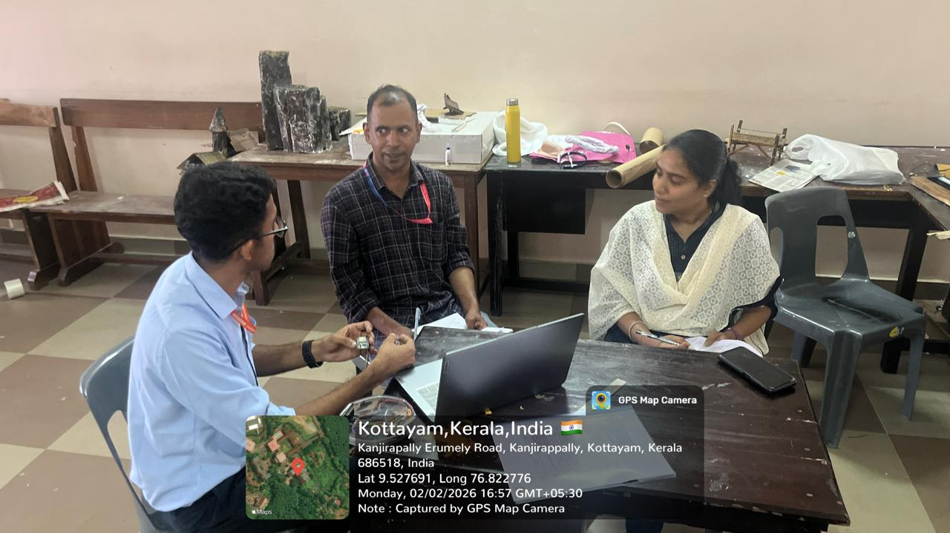

Git Log

